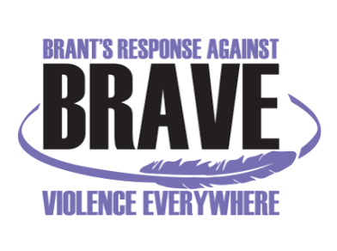
VIOLENCE THREAT RISK ASSESSMENT (VTRA) TRAINING: Level 1

Thursday, July 14th and Friday, July 15th, 2022
9:00am – 4:00pm
Pine Grove & Howell Community Centre
492 Lynden Rd., Brantford, N3T 5M1

Registration Form

Name:
Job Title:
Organization:
Telephone:
Email:
(Please provide email that only you have access to as this will be the email which you will be using to access your certificate from the NACTATR Client Portal)

Any dietary restrictions:

Fees: $100/person (Includes breakfast, lunch, light refreshments & training manual).

Please Note: In-person training is subject to COVID-19 restrictions at the time of the event.
As per COVID requirements, name and phone number of all participants will be provided to the venue. You will be required to show proof of COVID Vaccination (or alternative documentation as per updated Ontario Government guidelines) on the day of the training.

Your payment method:
Cheque (Payable to “Nova Vita”) via. mail (see mailing address below)

eTransfer to ap@novavita.org with message required indicating: “Payment for VTRA level 1 training, July 14th & 15th, 2022, for: (name/s of the attendee/s, name of the organization, and the number of attendee/s the organization is sending payment for)

Credit Card: Call Joanna Skinner at 519-752-1005 ext 218 to provide credit card information (Please do not provide credit card information via email)

Please RSVP and email your Registration Form latest by Friday, July 8th, 2022 to:
Renu Dhaliwal: BRAVE@novavita.org

BRAVE Committee Coordinator
Nova Vita Domestic Violence Prevention Services
59 North Park St., Brantford, ON N3R 4J8
Fax: 519-752-7590

