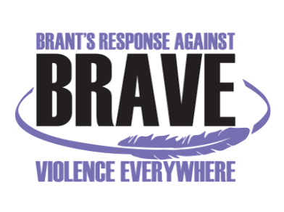
VIOLENCE THREAT RISK ASSESSMENT (VTRA) TRAINING
Level 1

Thursday, January 20th and Friday, January 21st, 2022 - 9:00 am – 3:30 pm
Location: Virtual

Registration Form

Name:
Job Title:
Organization:
Telephone:
Email:
(Please provide email that only you have access to as this will be the email which you will be using to access your certificate from the NACTATR Client Portal)

Fees: $ 50/person (Includes training manual).

Please Note: Upon registration you will be notified regarding when to pick up your training manual from Nova Vita.

Your payment method:
Cheque (Payable to “Nova Vita”) via. mail (see mailing address below)

eTransfer to ap@novavita.org with message required indicating: “Payment for VTRA level 1 training, Jan 20 & 21, 2022, for (name/s of the registrant or name of the organization and payment for how many registrants from the organization)

Credit Card: Call Joanna Skinner at 519-752-1005 ext 218 to provide credit card information (Please do not provide credit card information via email)

Please RSVP and email your Registration Form latest by Friday, January 14th, 2022 to:
Anita Menon: BRAVE@novavita.org

BRAVE Committee Coordinator
Nova Vita Domestic Violence Prevention Services
59 North Park St., Brantford, ON N3R 4J8
Ph.: 519-752-1005 ext 254; Fax: 519-752-7590

