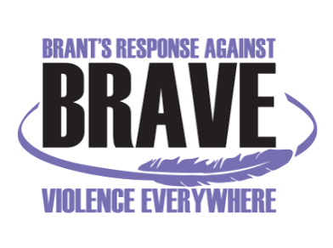
VIOLENCE THREAT RISK ASSESSMENT (VTRA) TRAINING
Level 2

Thursday, November 4th and Friday, November 5th, 2021 - 8:30 am – 4:30 pm
Location: TownePlace Suites By Marriott Brantford & Conference Centre
30 Fen Ridge Court, Brantford, ON N3V 1G2

Registration Form

Name:
Job Title:
Organization:
Address:
Telephone:
Email:

Any dietary restrictions:

Fees: $ 125/person (Includes lunch & training manual).

Please Note: In-person training is subject to COVID-19 restrictions at the time of the event.
As per COVID requirements, name and phone number of all participants will be provided to the venue. You will be required to show proof of COVID Vaccination (or alternative documentation as per updated Ontario Government guidelines) on the day of the training.

Your payment method:
Cheque (Payable to “Nova Vita”) via. mail (see mailing address below)

eTransfer to ap@novavita.org with message required indicating: “Payment for VTRA level 2 training, Nov 4-5, 2021, for (name/s of the registrant or name of the organization and payment for how many registrants from the organization)

Credit Card: Call Joanna Skinner at 519-752-1005 ext 218 to provide credit card information (Please do not provide credit card information via email. We are doing our due diligence to safe guard sensitive information as we continue to navigate working from home & on site.)

Please RSVP and email your Registration Form latest by Tuesday, October 19th, 2021 to:
Anita Menon: BRAVE@novavita.org

BRAVE Committee Coordinator
Nova Vita Domestic Violence Prevention Services
59 North Park St., Brantford, ON N3R 4J8
Ph.: 519-752-1005 ext 254; Fax: 519-752-7590

