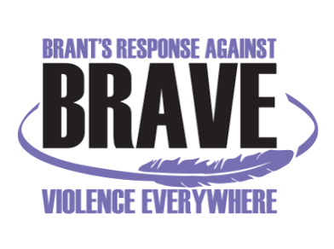
VIOLENCE THREAT RISK ASSESSMENT (VTRA) TRAINING
Level 2

Wed, November 11th and Thur, November 12th, 2020 - 8:30 am – 4:30 pm
Virtual via Zoom

Registration Form

Name:
Title:
Organization:
Address:
Telephone:
Email:

Fees: $50/person (Includes training manual)

Your payment method:  Cheque (Payable to “Nova Vita”)  Credit Card | Paying:  Via. Mail

Please RSVP and email your Registration Form latest by Wednesday, October 14th, 2020 to:
Anita Menon: BRAVE@novavita.org or amenon@novavita.org

BRAVE Committee Coordinator
Nova Vita Domestic Violence Prevention Services
Ph.: 519-752-1005 ext 254
Fax: 519-752-7590

For payment with Credit Card: Visa Master Card

Name on the card (Print):
Card Number:
CV #
Expiry Date:
Signature

