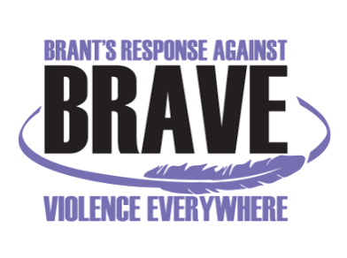
TRAUMATIC EVENT SYSTEM (TES) MODEL TRAINING
With KEVIN CAMERON

Tuesday, Nov 5th & Wednesday, Nov 6th, 2019 - 8:30 am – 4:00 pm
Hampton Inn, 20 Fen Ridge Ct., Brantford, ON N3V1G2 – Espero Room

Registration Form

Name:
Title:
Organization:
Telephone:
Email:

Fees: $150/person (Includes lunch for both days, and training manual) (Subsidies available if needed)

Any dietary restrictions:

Your payment method:
Cash
Cheque (Payable to “Nova Vita”)
Credit Card

For payment with Credit Card: Visa Master Card

Name on the card (Print):
Card Number:
Expiry Date:

Paying:
On the day of the training
Via. Mail

Please RSVP and email your Registration Form by Monday, October 28th, 2019 to:
Anita Menon: BRAVE@novavita.org or amenon@novavita.org

Interim BRAVE Committee Coordinator
Nova Vita Domestic Violence Prevention Services
Ph.: 519-752-1005 ext 254
Fax: 519-752-7590

