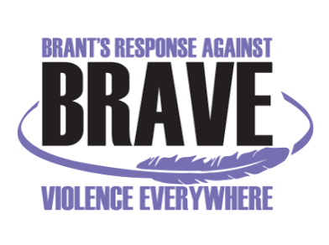
VIOLENCE THREAT RISK ASSESSMENT (VTRA) TRAINING
Level 1: Theory and Practice

Mon, Nov 25th & Tue, Nov 26th, 2019 - 8:30 am – 4:00 pm
Nova Vita Domestic Violence Prevention Services, 59 North Park Street, Brantford, ON N3R4J8

Registration Form

Name:
Title:
Organization:
Telephone:
Email:

Any dietary restrictions:

Fees: $100/person (Includes lunch for both days, and training manual) (Subsidies available if needed)

Your payment method:  Cash  Cheque (Payable to “Nova Vita”)  Credit Card | Paying:  On the day of the training  Via. Mail

Please RSVP and email your Registration Form by Monday, September 9th, 2019 to:
Anita Menon: BRAVE@novavita.org or amenon@novavita.org

Interim BRAVE Committee Coordinator
Nova Vita Domestic Violence Prevention Services
Ph.: 519-752-1005 ext 254
Fax: 519-752-7590

For payment with Credit Card: Visa Master Card

Name on the card (Print):
Card Number:
CV #
Expiry Date:
Signature

