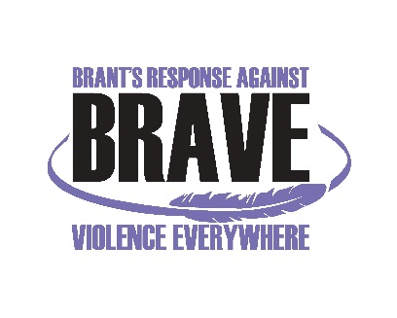
Statement of Support
Released: July 19th, 2017
BRAVE (Brant Response Against Violence Everywhere) stands united in solidarity with Indigenous communities and their decision to request a restructuring of the National Inquiry on Missing and Murdered Indigenous Women, Girls, Trans &Two-Spirit (MMIWGT2S)
BRAVE is a multi-sector community coordinating committee comprised of agencies across Brantford, Brant County, and Six Nations of the Grand River that are committed to domestic violence and sexual violence prevention and response work across Turtle Island. As an organization that advocates for improvements in existing systems, it is our honor and privilege to be able to stand in solidarity with Indigenous Nations and allies alike, as they attempt to dismantle the current colonial structure that is inadequately representing the Inquiry into the missing and murdered Indigenous women, girls, trans & two-spirit (MMIWGT2S).
BRAVE recognizes the epidemic of the MMIWGT2S is part of a much larger issue rooted in discrimination, racism, and tolerance for violence perpetuated against Indigenous peoples, in particular, Indigenous women. Our organization stands in support with Indigenous communities across Canada that are currently advocating to have their culture, traditions, and intersectional lenses represented throughout this process.
The Inquiry into the MMIWGT2S is a step towards reconciliation and thus should be structured to accommodate Indigenous perspectives and values. The high rates of extreme violence Indigenous women face in this country needs to be addressed, but it is the belief of the BRAVE committee that this critical issue should be addressed in an inclusive and respectful manner that allows for healing and avoids re-victimization.
BRAVE will be joining Six Nations in honoring the spirits of the MMIWGT2S on July 31st, 2017. They have proposed an International Day of Ceremony and we would like to encourage other agencies in the surrounding area to show their support and consider participation.
In solidarity,

Joanna Brant and Penny McVicar
Co-Chairs, BRAVE Committee

